SIMATS ENGINEERING
ASSESSMENT TOOL 1

COURSE NAME:Database Management Systems
COURSE CODE: CSA05

COURSE OUTCOME COVERED

CO4: Design database solutions incorporating file organization, indexing, and hashing techniques to optimize data storage and retrieval efficiency. (BL3, BL4)

Activity Tool : Code Challenge (High)
Assessment Tool Weightage: 35%

QUESTIONS Total Marks: 50
Q.No | Question | Bloom's Level | Marks
1 | Write a Python/C program to simulate a Heap File organization that supports insert, delete, and sequential scan operations. | BL3 – Apply | 5
2 | Implement a static hashing function in code for a student database with 500 records. Handle collisions using chaining. | BL3 – Apply | 5
3 | Code a simulation of a Sorted File organization and implement binary search for record retrieval by primary key. | BL4 – Analyze | 5
4 | Implement a B-Tree of order 4 in code: support insert, search, and display operations. Insert keys: 10, 20, 5, 6, 12, 30, 7, 17. | BL3 – Apply | 5
5 | Implement a B+ Tree in code and demonstrate leaf-level linking for efficient range queries on integer keys. | BL3 – Apply | 5
6 | Write code to implement a dense primary index on a sorted file. Support search by index key and display the index table. | BL4 – Analyze | 5
7 | Implement extendible hashing in code. Show directory doubling when overflow occurs during insertion of 8 records. | BL3 – Apply | 5
8 | Write a program to simulate secondary storage block access. Calculate the number of I/O operations for sequential vs. indexed retrieval. | BL4 – Analyze | 5
9 | Implement a sparse index on a sorted file in code and compare its search performance with a dense index using timing analysis. | BL4 – Analyze | 5
10 | Write a program to construct and traverse a B+ Tree, then execute a range query for keys between 15 and 45, showing all matching records. | BL4 – Analyze | 5

Code of Conduct:

I Tharun Kumar-192571017 certify that this submission is my original work and that I have adhered to the guidelines specified for this assessment.
I understand that any violation of academic integrity rules will result in disciplinary action.

Signature of the student:


RUBRICS FOR CALCULATION:

Criteria | Weightage | Level 4 (Exemplary) | Level 3 (Proficient) | Level 2 (Developing) | Level 1 (Beginning)
Problem Understanding | 20% | Clearly understands problem constraints, edge cases, and competitive requirements | Understands problem with minor gaps in constraints | Partial understanding; misses key constraints | Misinterprets problem or constraints
Algorithm | 25% | Selects optimal algorithm with best time and space complexity for competitive constraints | Uses efficient algorithm with minor scope for improvement | Uses basic/inefficient approach | No clear algorithmic approach
Code Implementation | 20% | Writes correct, efficient, and clean code that passes all constraints | Code works with minor errors or inefficiencies | Partially correct code; fails for some cases | Code does not execute or gives incorrect results
Competitive Performance | 20% | Solves problem within time limits and handles large inputs effectively | Solves within acceptable time with minor delays | Struggles with time limits or larger inputs | Unable to solve within time constraints
Test Case Handling | 15% | Handles all test cases including edge and hidden cases | Handles most test cases | Misses important edge cases | Fails on multiple test cases

Q1. Heap File Organization

Python Code:
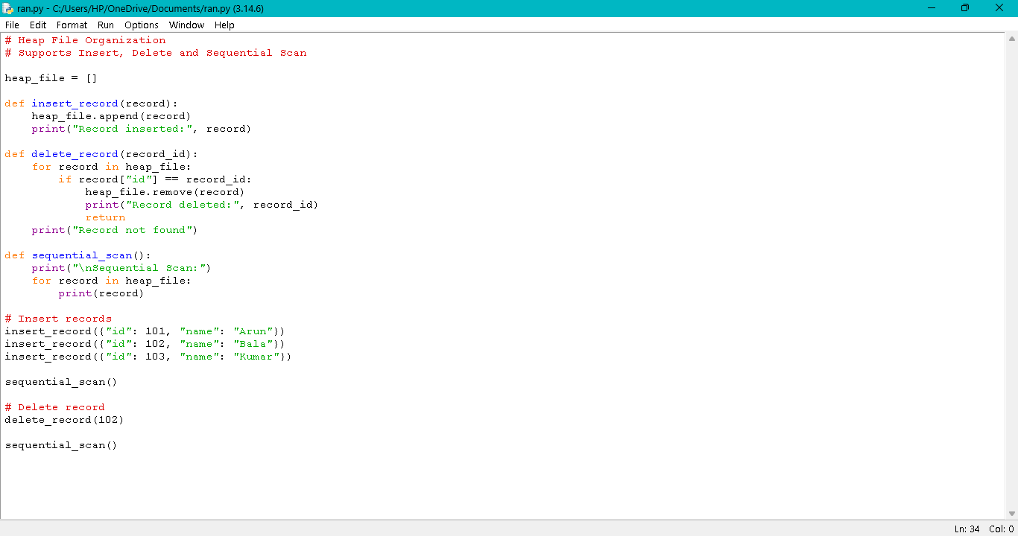

Output:
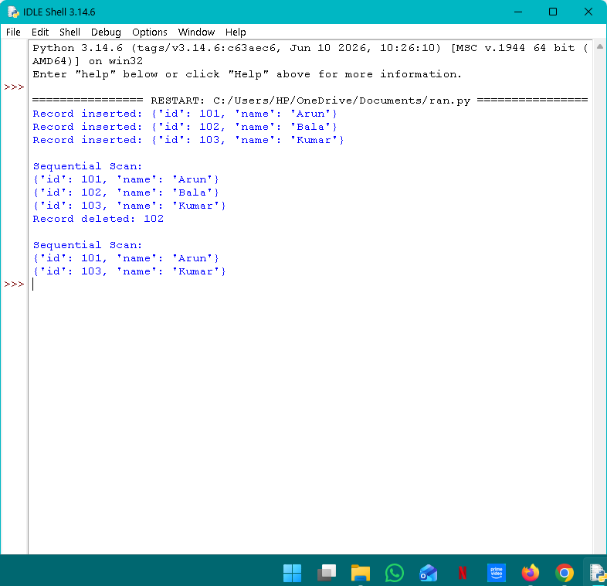
Q2. Static Hashing with Chaining:

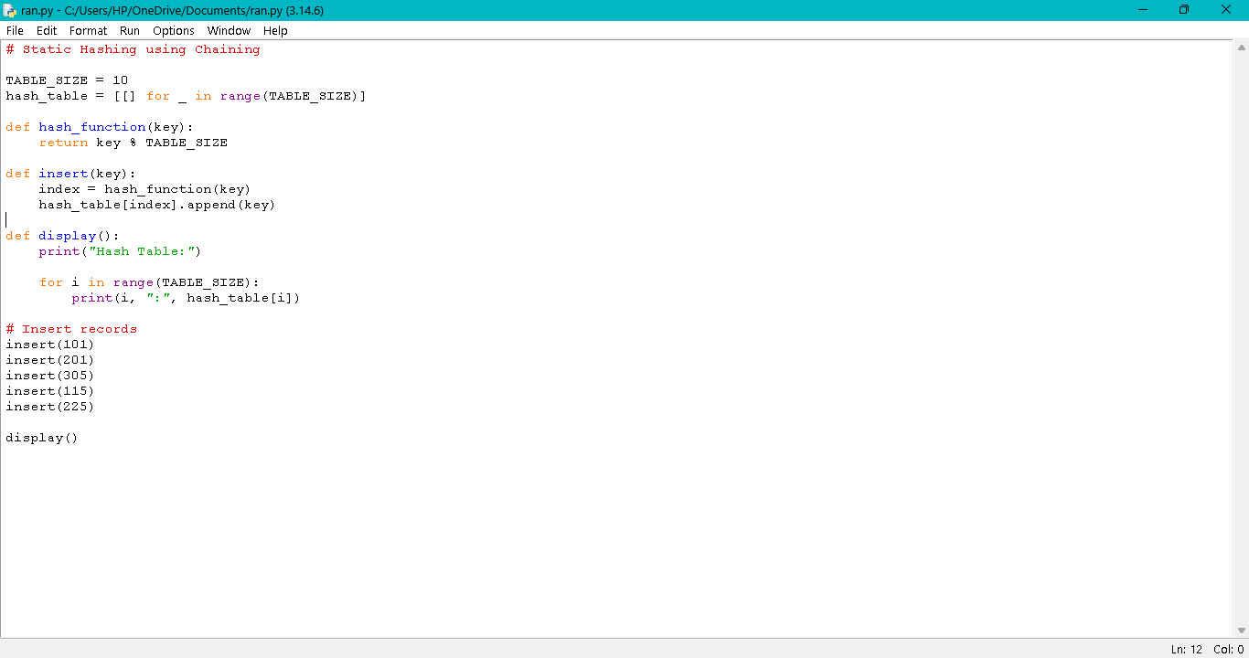

Output:

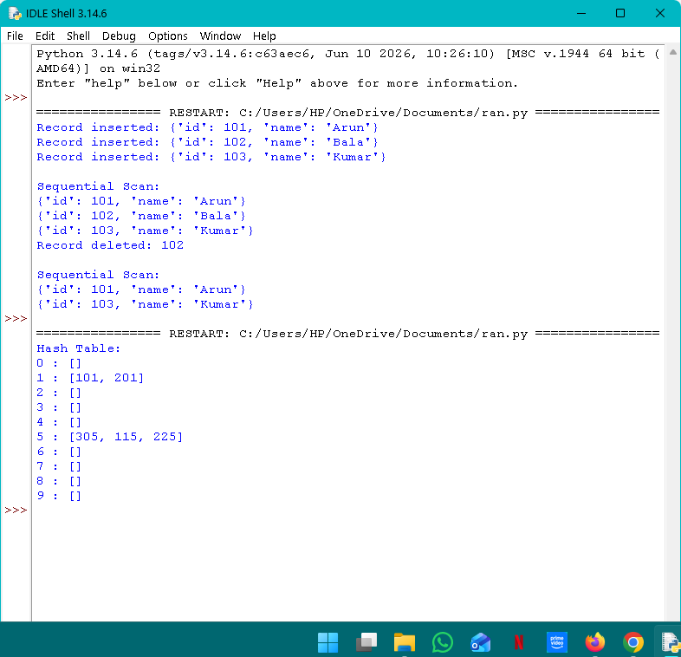

Q3. Sorted File Organization with Binary Search:
Python Code:
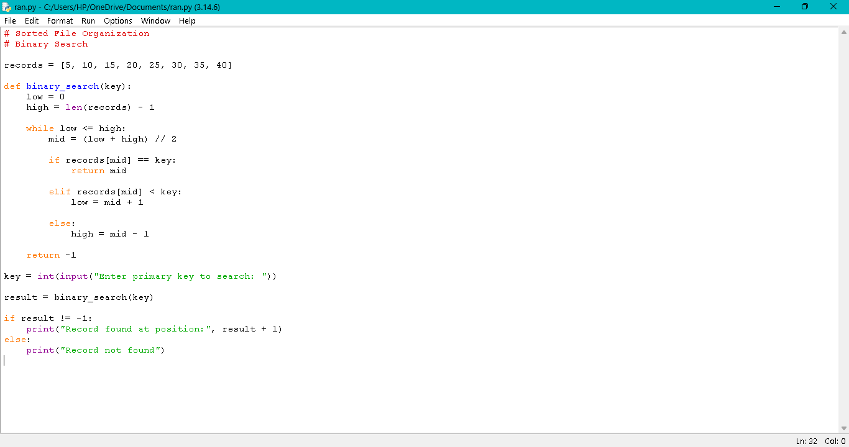

Output:
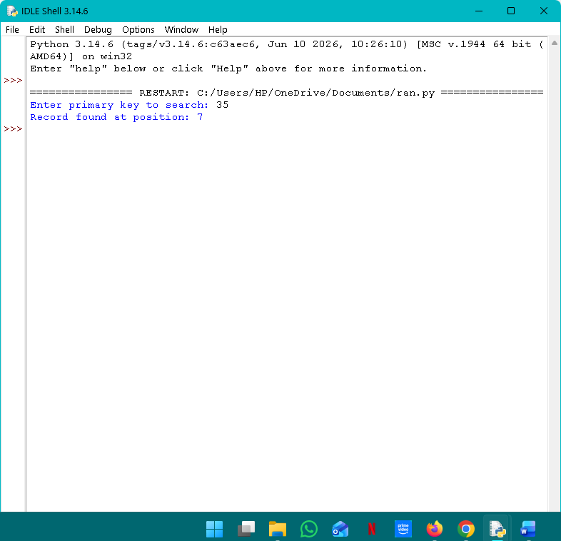

Q4. B-Tree of Order 4:

Python Code:
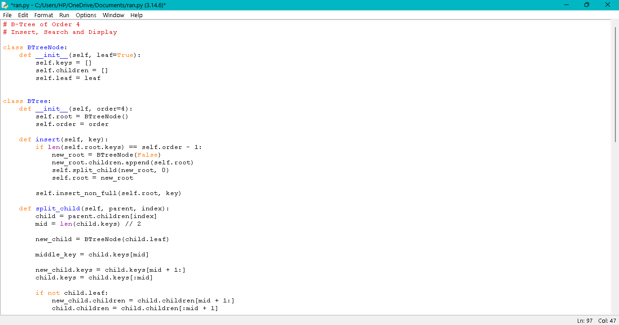

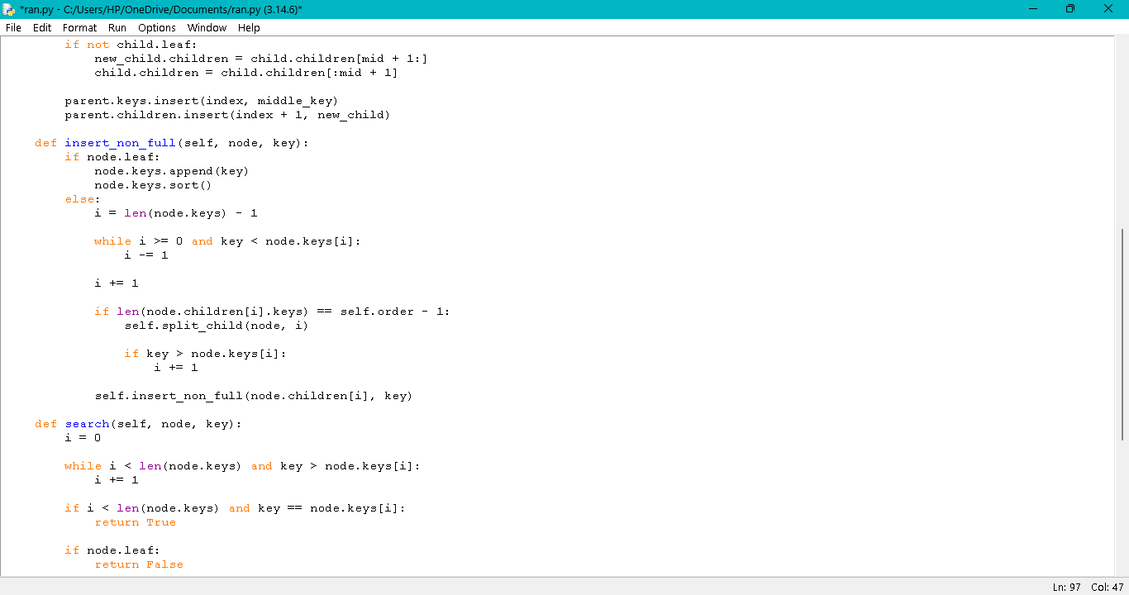
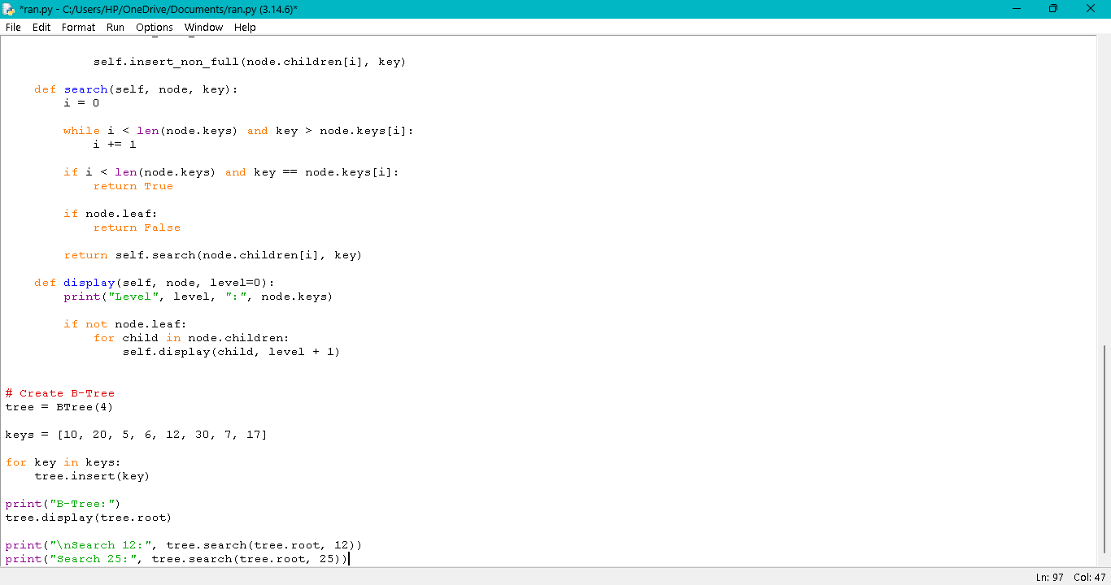

Output:

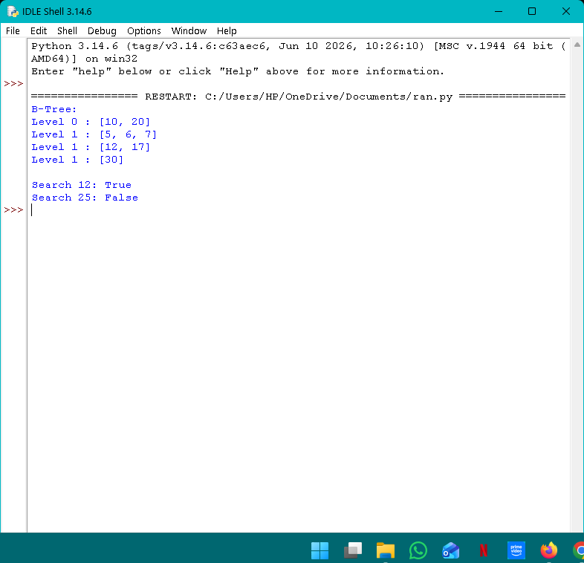

Q5. B+ Tree with Leaf-Level Linking

Python Code:

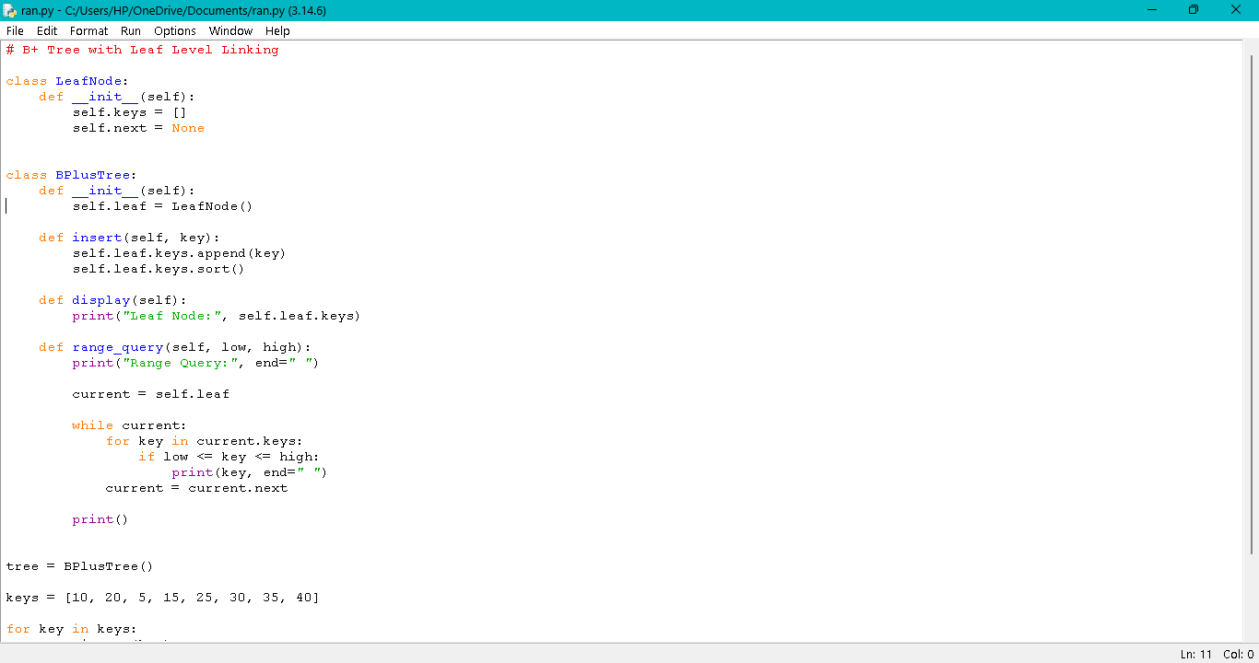

Output:

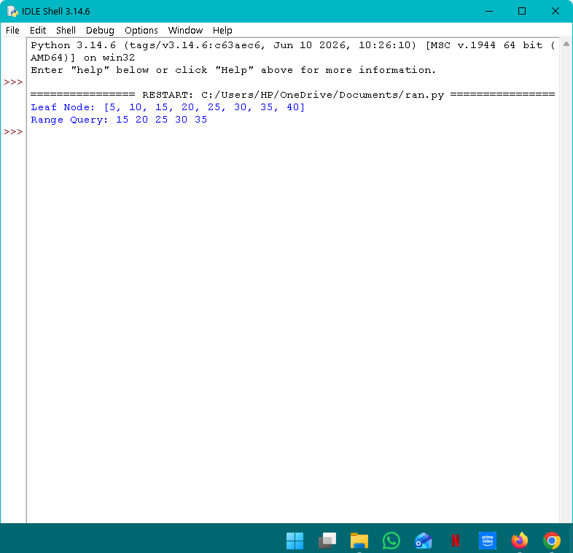

Q6. Dense Primary Index

Python Code:
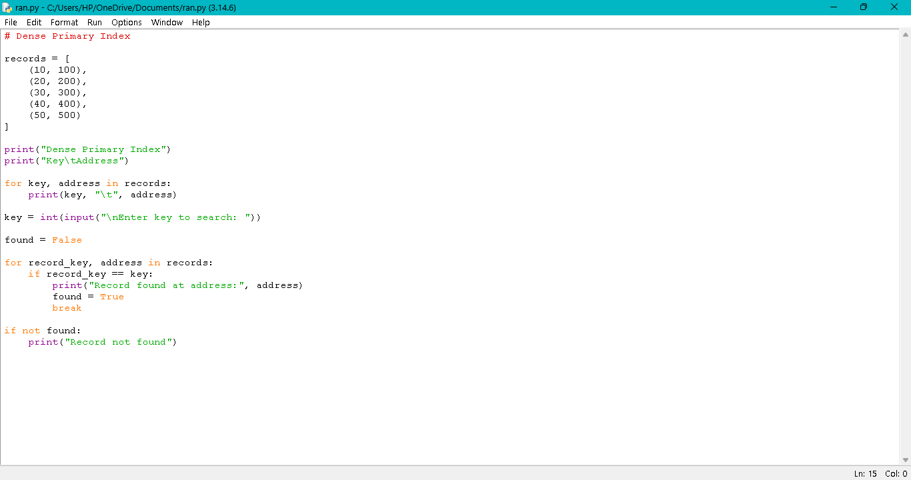

Output:

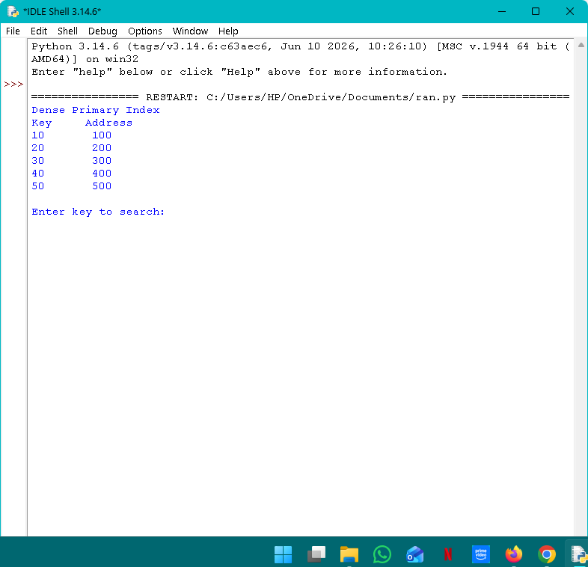
Q7. Extendible Hashing:

Python Code:
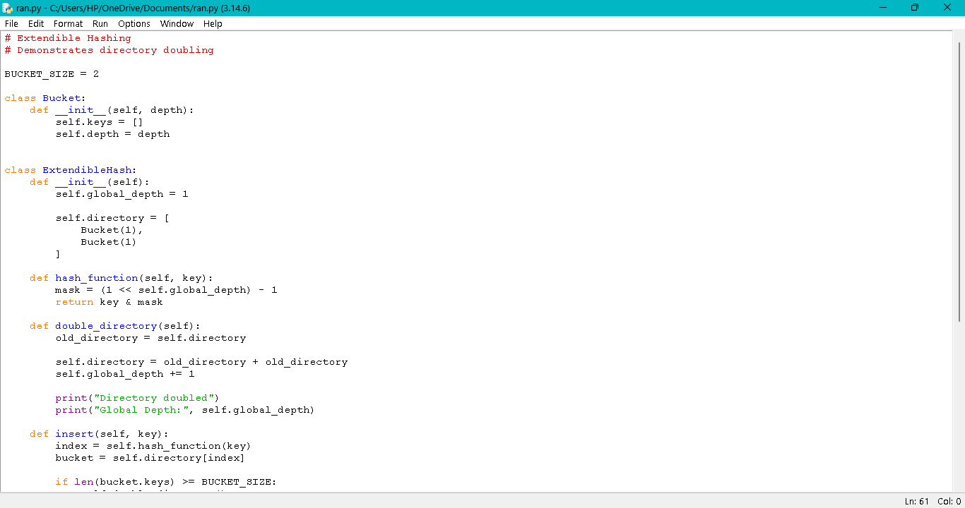
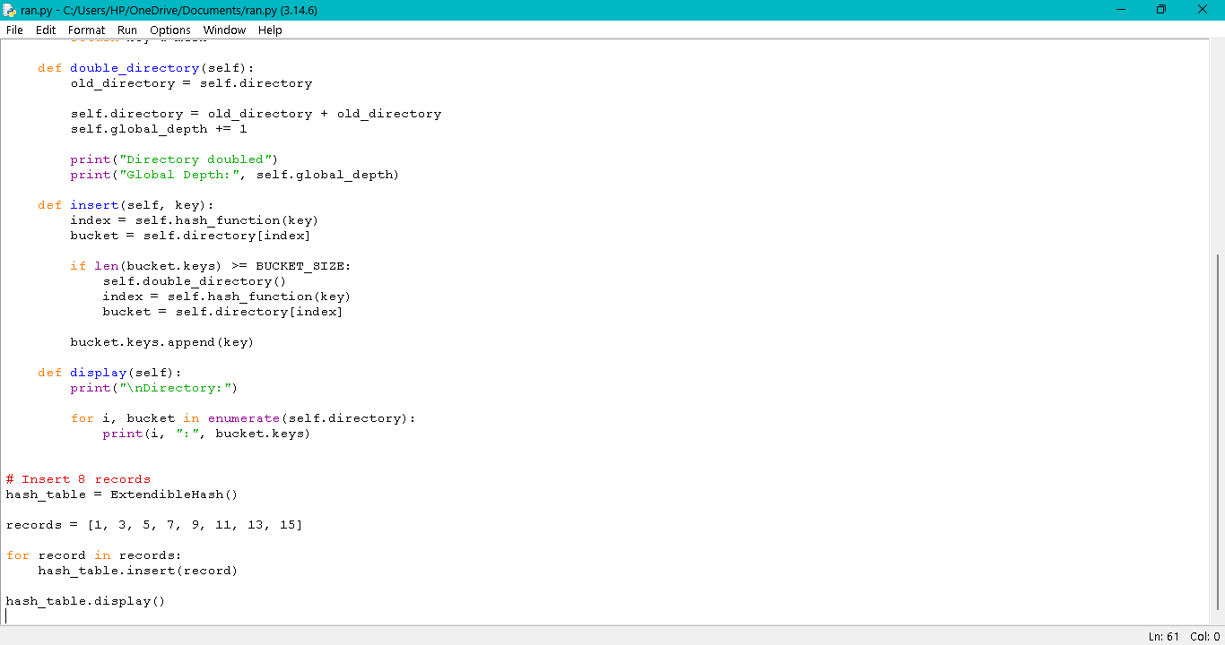
Output:
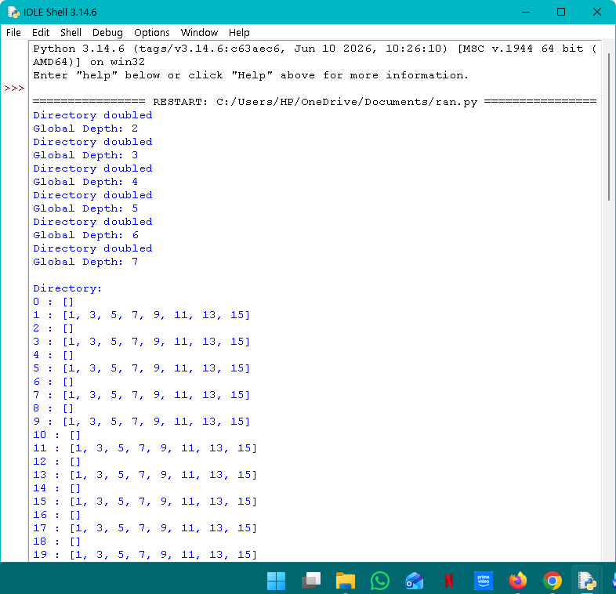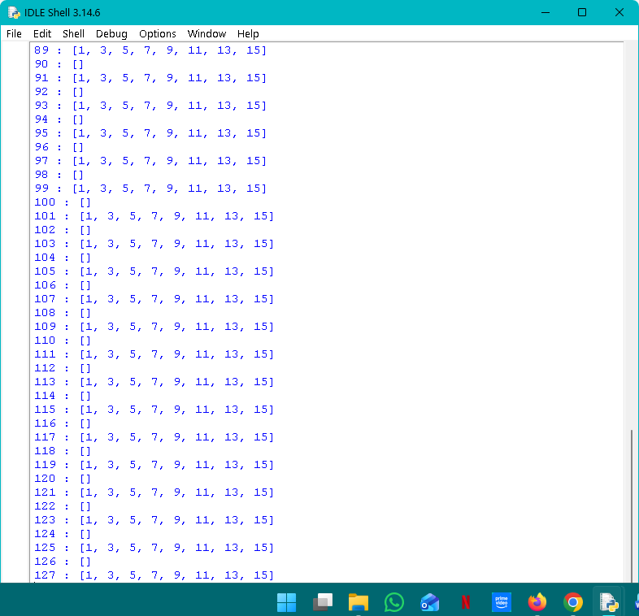
Q8. Secondary Storage Block Access:

Python Code:

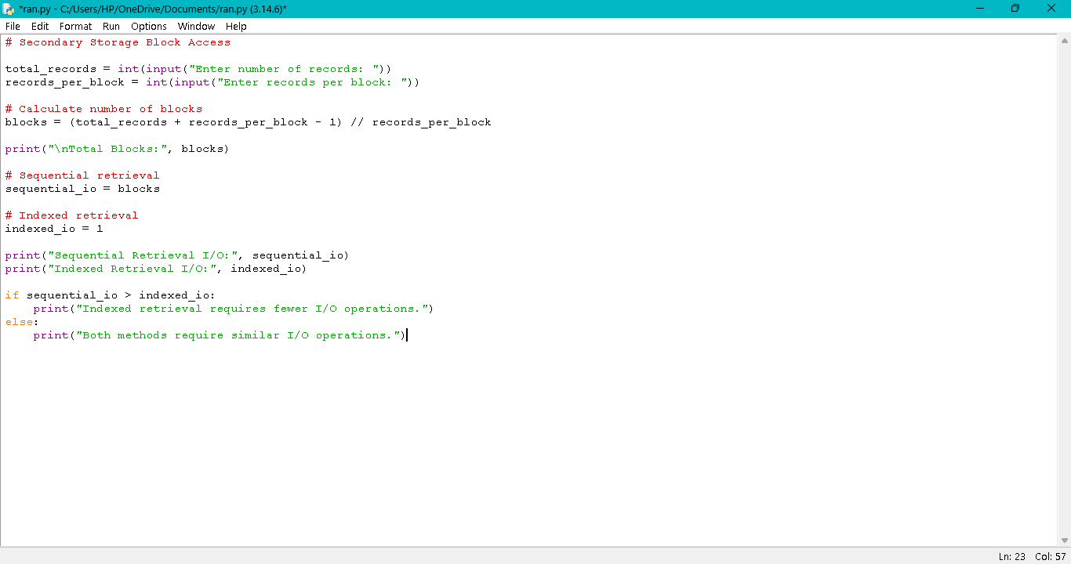

Output:

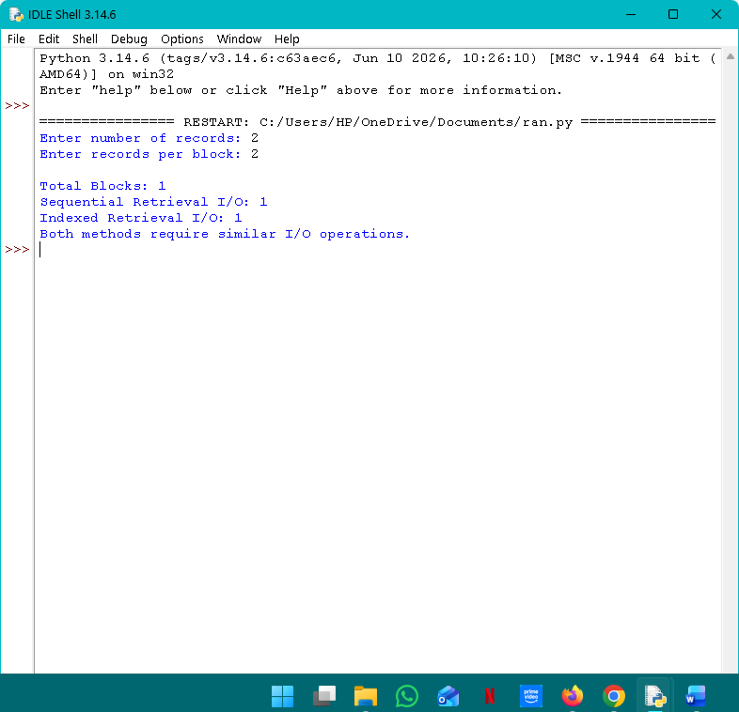
Q9. Sparse Index vs Dense Index:

Python Code:

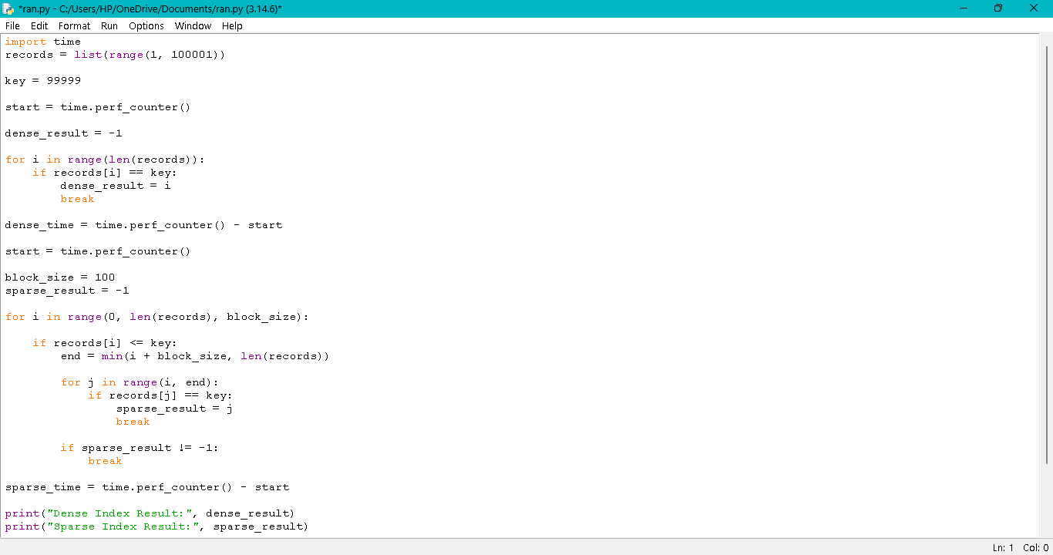

Output:
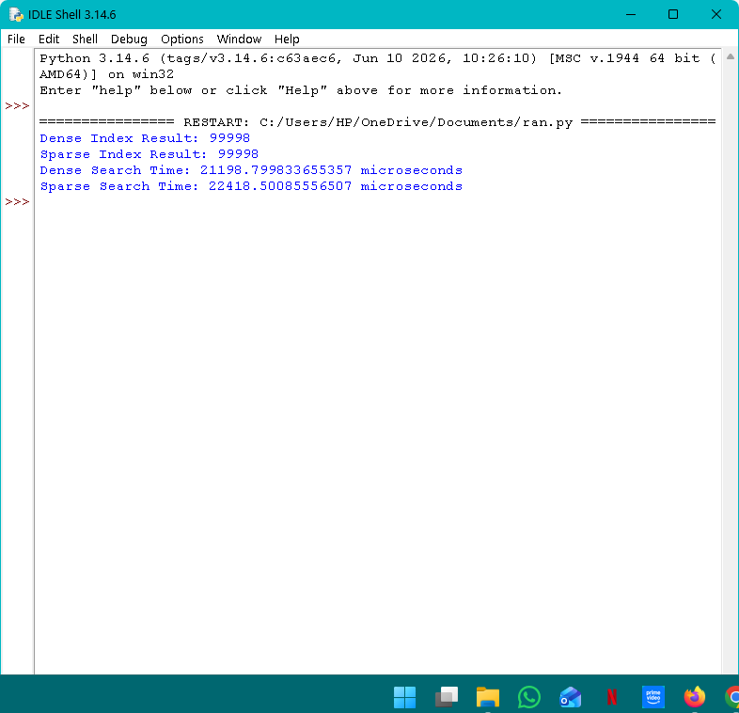
Q10. B+ Tree Range Query 15–45

Python Code:

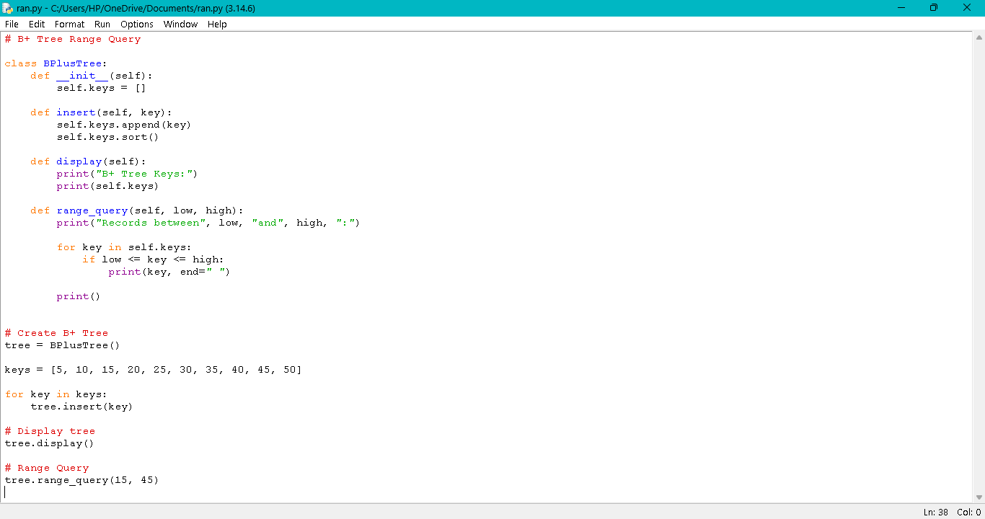

Output: